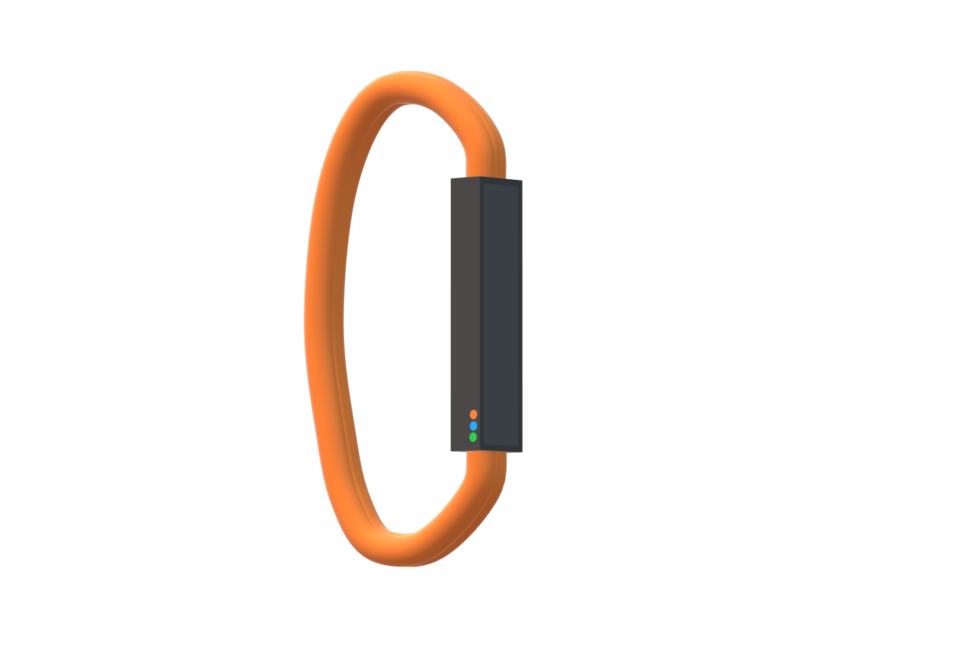

Project: Pebble

Name: Tanvir Bhachu

Team: Karan Thakur, Kunwar Singh

Table of Contents

Introduction 3

What goals did you set for your project? 3

Did your group achieve the goals you set for your project? 3

What will success for your project look like? 3

How will you know that you have been successful? 3

Describe the three (3) best qualities of your project. 4

Describe the three (3) weak qualities of your project. 4

If you could experience this project again, list five (5) activities you would change. 4

Discuss the skills that each member of the project team contributed to the final project. 5

Describe how your project will support the United Nations in achieving their goal – based on your nominated Sustainable Development Goal 5

Additional comments or suggestions 5

Conclusion 6

# Introduction

My group, myself along with Karan Thakur and Kunwar Singh, created a product called Pebble. Pebble focuses on 2 main things: Helping teachers manage their classes efficiently and helping students with how they work at school. Pebble reduces workloads and increases workflows and also creates a rich collaborative environment. I handled the software aspect of Pebble by creating the desktop application, website and software I created to showcase our report and pictures digitally. The manufacturing of Pebble was done by Kunwar Singh and the marketing and pictures were done by Karan Thakur. We finished a making a 3d showcase of our product but unfortunately it was functional and this is the reason for us not placing top 3.

# What goals did you set for your project?

We had three main goals in mind. First was to produce a functional product along with a functioning software. Next, we wanted to make it industry-grade by putting many useful features and have a clean and aesthetic design. Finally, we wanted to win the competition and make ourselves, our families, our team and our teacher proud.

# Did your group achieve the goals you set for your project?

Unfortunately, we didn’t reach any of these goals which make me think that all my time was wasted and I lost hours of sleep for nothing but I have learned many things from this failure and next year and I going to make sure that I win. Our product wasn’t functional at all mostly because my a member of my team took an awful lot of time with getting the components which made our project more difficult down the line. While the software was finished and ready to go, we didn’t have any parts functioning together. Since the product wasn’t finished, we also did not achieve the second goal of making an industry-grade product. Because of this, we didn’t win and I know it was because of this since I asked the judges.

# What will success for your project look like?

For our product, success would mean winning the competition and then taking the project to a national level. I think that the idea of Pebble was really nice and it would’ve have helped education facility across the nation and even the world. We would have been improving the design and features and be working on selling our product worldwide.

# How will you know that you have been successful?

I would know that we were successful if we had won the competition and were working on an even better Pebble. Unfortunately, we didn’t even place top three so I will most likely not be working on the idea in the future. Since we didn’t win, I can conclude that we didn’t work hard enough we were not successful. Next year, I will make that my team and I are successful by working hard and producing an amazing product.

# Describe the three (3) best qualities of your project.

For starters, our software was amazing and was really interactive. I could even say that it was my best software created yet because of the time, design process, interactivity and the different components and researching it took to create it. Our presentation looked really good and I think Karan did a petty good job at getting the pictures and marketing finished. It made our showcase look better and made people interested in our product. While we didn’t even start the functional product because Kunwar took so long to get components that weren’t even properly researched, the 3d model that we showed at the competition did look pretty nice and he did try his best.

# Describe the three (3) weak qualities of your project.

The reason we lost was that Pebble wasn’t functional so the software couldn’t be connected with Pebble and it didn’t have any working parts which made it look it look poorly made. The report, design process and video could all have been improved and made to look professional however since we started off poorly and didn’t take it seriously enough it was hard to make it look professional. Our speech was also not too great. While it talks about a lot of things, it didn’t go deeply into everything which made the project seem lazy and not that great. Next year, I will make sure to work on the weak aspects of the project to make sure we weren’t lacking anything.

# If you could experience this project again, list five (5) activities you would change.

Before a hadn’t been in a fully competitive environment because I had mainly done the competition in my free time however this time it was different because I was up against people who knew what they were doing. If I did experience this project again I would make sure that I was working faster and more efficiently. While working fast, I would also make sure that my work was at a high standard because my video and report for this project were not up to my standard. I would make sure my team is working hard because my team for this year didn’t do much at the start which made it harder for us at the end. I would come up with an idea that was actually achievable and that my team could handle because I think we bit off more than we could chew this year. And finally, I would win the competition because I know I have the skills however I feel like I didn’t put my all this year.

# Discuss the skills that each member of the project team contributed to the final project.

I spent my time creating the software. This included making a website, desktop application and a special application made to showcase our project digitally. I got all this done and manage my team and tried to make things easier for them by providing my experience.

Karan worked on the marketing which included taking pictures, making stuff for our display and coming up ideas. He did a good job of getting different pictures and important details of our project and showcasing them.

Kunwar worked on researching the components for Pebble and then spent his time creating a 3d model of Pebble which he printed out and this allowed us to show what our finished product was going to look like.

# Describe how your project will support the United Nations in achieving their goal – based on your nominated Sustainable Development Goal

Pebble helps solve the challenge of Quality Education by making learning easier and more efficient and also helps by reducing wasted time on things like attendance. Every day we make new breakthroughs and we need to add more content to the curriculum and to help student and teacher cope with this, Pebble can help with teaching more in shorter amounts of time. Pebble can be used to manage corporate workplaces since they are quite similar to a classroom environment but instead with managers and employees rather than teachers and students.

# Additional comments or suggestions

I think that many people were lacking the skills needed for coding and engineering. So I think some prerequisites need to be set for the subject because I feel like people were put into a situation that they didn’t know what to do in and I saw this with my team. This is why I will be working on my skills because programming and engineering look easy but it goes very deep and we tackled a project that we didn’t have the skills for.

Another thing is, people didn’t know much about electrical engineering such as working with Arduinos, displays and other modules. I think the school needs to teach students about this kind of stuff especially to students who are taking coding and robotics because the coding part is easy but the robotics part is hard.

# Conclusion

While we did try and win the competition, we started taking the project seriously too late. We were working on things that other groups had finished weeks ago. Not only that but our standard of work was not up to my level. I have concluded that we tried to do something that we weren’t ready for. After thinking over my project, I know now that if you start up right then it will be easier at the end. Therefore, while I didn’t do so great this year, I definitely know what to work on and improve on next year. Until then I will work on my skills and make sure that I can handle high-level projects.